**아이템 구매 버튼**

1. **[StarterGui] 🡪 [ScreenGui] 🡪 [Frame01] 🡪 [TextButton]**

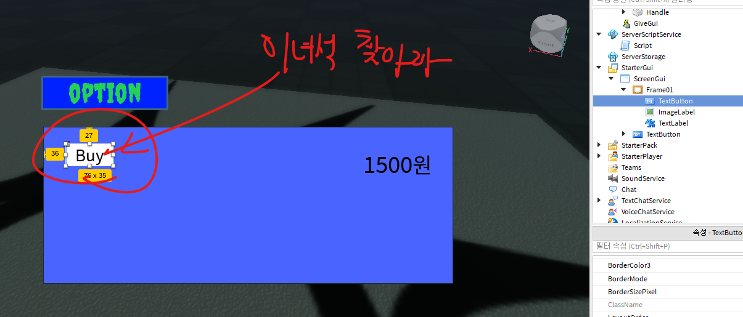

1. **[TextButton][+] 🡪 [LocalScript] 생성**

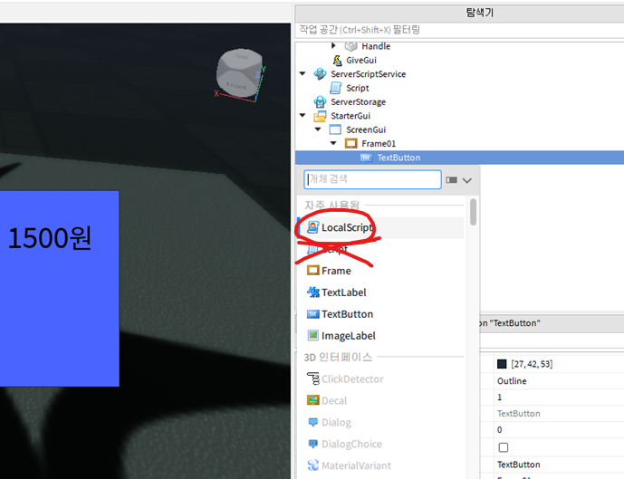

1. **[LocalScript] 작성**

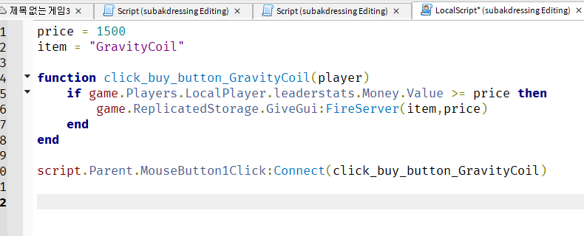

1. **구입 확인**

